[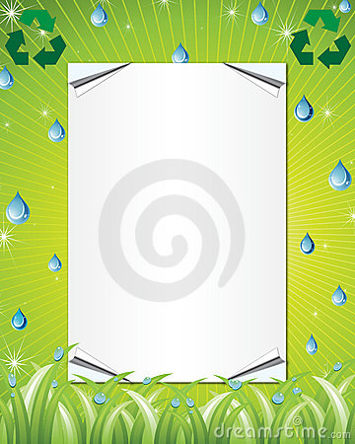](http://www.google.co.uk/url?sa=i&rct=j&q=&esrc=s&frm=1&source=images&cd=&cad=rja&uact=8&ved=0CAcQjRw&url=http://es.dreamstime.com/imagenes-de-archivo-blindaje-de-eco-image28614174&ei=G3XwVMvQFYve7AbmxIGIDA&bvm=bv.87269000,d.ZGU&psig=AFQjCNG5WGPzehIIgf5lfq3QK0wDt2VbOQ&ust=1425131136697166)

**Our Eco Code.**

At *St Teresa’s Primary School* we **Recycle**

paper, plastic and bottles too!

We make compost in the bin,

With apples, oranges and banana skins!

Compost is cool, it’s made from fruit

Use it to plant and don’t pollute.

We **Reduce** waste, take part in The Big Spring Clean,

Feed the birds and plant flowers to be seen!

Turn off the lights when you go away

Or when we go outside to play.

We **Reuse** containers for our lunch

We really are a happy bunch.

Pick up the Litter, don’t be Bitter!

Keep Our Planet clean,

Come on everyone, Let’s BE Green!